

Name: Syed Shaheer Ali Shah

Reg : FA20-BCS-079

Department: BCs- 2C

Subject: Programming Fundamental

Subject Teacher: Sir Ali Iqbal

1-Write a program to calculate the x raised to the y power using a for iteration control statement.

#include<stdio.h>

int main()

{

int x,y,i,ans=1;

printf("Enter a value\n ");

scanf("%d",&x);

printf("Enter their power\n ");

scanf("%d",&y);

for(i=1;i<=y;i++)

{

ans=ans\*x;

}

printf("Your answer is %d",ans);

return 0;

}

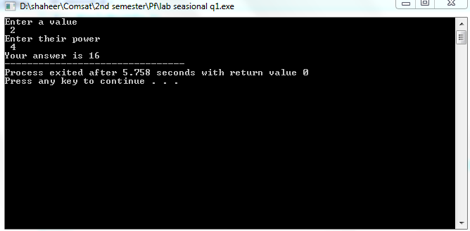

2- Multiplication table using for loop from 1 to 10 using input from user.

#include<stdio.h>

int main()

{

int a,i;

printf("Enter a number to print their table\n");

scanf("%d",&a);

for(i=1;i<=10;i++)

{

printf("%d \* %d = %d\n",a,i,a\*i);

}

return 0;

}

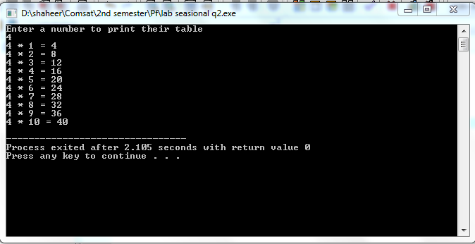

3-Write a program that uses looping to print the following table of values..



#include<stdio.h>

int main()

{

int i,j;

printf("N\t10\*N\t100\*N\t1000\*N\n");

for(i=1;i<=10;i++)

{

for(j=i;j<=1000\*i;j\*=10)

{

printf("%d\t",j);

}

printf("\n");

}

return 0;

}

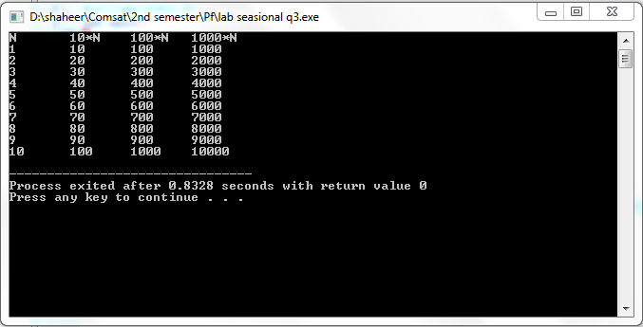

5.Write a Program to check whether the given number is Prime or Not??? program keep asking user “enter another number unless user input -1 to terminate the program”

#include<stdio.h>

int main()

{

int a,i;

printf("Enter a number to check weather it it prime or not\n");

scanf("%d",&a);

ss:

for(i=2;i<=a;i++)

{

if(a%i==0&&a!=i)

{

printf("Not a prime number\n");

printf("Enter a number again to check weather it it prime or not\n");

scanf("%d",&a);

if(a!=1)

{

goto ss;

}

else

{

break;

}

}

if (a%i==0&&a==i)

{

printf("prime num is %d\n",a);

printf("Enter a number again to check weather it it prime or not\n");

scanf("%d",&a);

if(a!=1)

{

goto ss;

}

}

}

return 0;

}

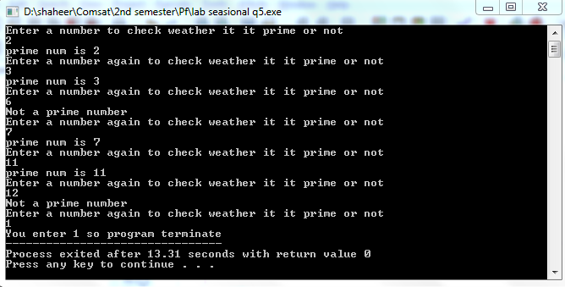

4.Develop a class averaging program that will process an arbitrary number of grades each time the program is run,

#include<stdio.h>

int main()

{

int a,sum=0,i=0;

float aver;

printf("Enter the grade of students and -1 to terminate \n");

scanf("%d",&a);

do

{

sum=sum+a;

scanf("%d",&a);

i++;

}while(a!=-1);

aver=(float)sum/i;

printf("Class average are %.2f",aver);

return 0;

}

